Session Name: Common Mental Disorders
  - Academic Responsible for Session: Suzanne Reeves (Suzanne.reeves@ucl.ac.uk)

Intended Learning Outcomes (ILOs) (in relation to curriculum mapping)
- Recognise the mental health continuum in relation to common mental disorders
- Develop skills to elicit a history and carry out a mental state examination in relation to common mental disorders in medical settings.
- Recognise commonly used psychiatric treatments and develop a broad understanding of the stepped care approach to common mental disorders
Taking a thorough psychiatric history and performing a competent mental state examination are essential clinical skills for all medical students and ‘active listening’ is a key component. This session aims to build on existing knowledge through video-assisted learning and case-based discussion of anxiety and panic symptoms.
The symptoms of a panic attack overlap with those of common medical conditions and it is important that you know how to recognise it and how to respond appropriately regardless of the context (medical or public setting).
The request ‘is there a doctor on the plane/train/ship, we need their assistance’ is not uncommon and, based on my own experience, at least one in five of the people you may be asked to assist will be experiencing anxiety and/or panic.
Specific Learning Objectives
- To improve skills in psychiatric history taking in people with panic symptoms
- To improve skills in recording and presenting key mental state examination findings in a person with severe anxiety
- Understand stepped care approaches to helping a person with panic attacks
Session Plan
Part 1 (Panic attacks): Primary Care setting
History taking
You will be asked to watch a video of a woman who is being interviewed by her GP, and will be asked to write down the key points in relation to her presenting complaint and its history. https://www.youtube.com/watch?v=Ii2FHbtVJzc
First of all reflect on the GP herself, as she is an active listener. Can you recall what active listening involves?

Active listening skills are shown in the Figure below
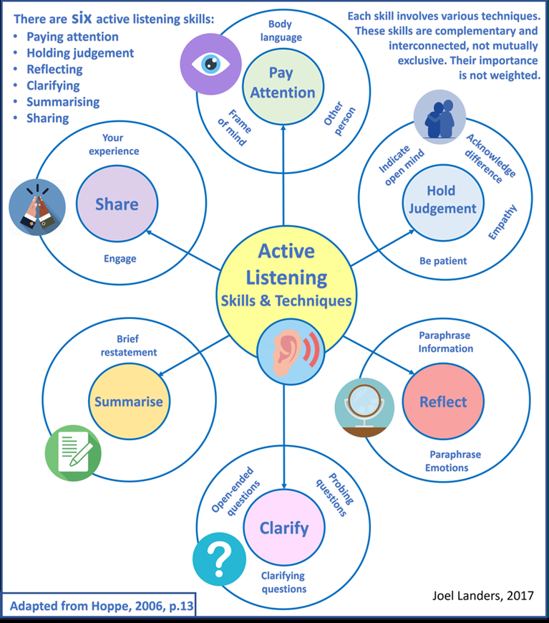
Things to consider in the presenting complaint:
- Panic disorder requires there to be recurrent episodes of severe anxiety
- Not linked to particular trigger
- Palpitations, chest pain, choking, dizziness and depersonalisation common
- Almost always associated with a fear of dying, losing control or going mad
- Attacks usually last minutes, sometimes longer
- Leads to avoidance of situations where would feel panicky

History of presenting complaint:
- The first attack happened six months ago, at a time when she was under work pressure.
- There was no specific trigger on the day it happened
- Attacks are recurrent, and have led to her seeking medical help for her ‘heart’.
- She is now avoiding exercise, is afraid to go out alone, and it is affecting her relationship with her husband both socially and in terms of sexual intimacy.
Other relevant questions include:
- Past psychiatric history
- Depression, generalised anxiety, agoraphobia .
- Did she have any social, psychological or drug based interventions and, if yes, does she feel they helped.
- Past medical history of physical health problems that can be associated with anxiety eg hyperthyroidism, cardiac history, respiratory illness, neurological conditions.
- Family history of mental illness, including anxiety, or FH of physical illness that may have heightened her anxiety regarding her ‘heart’ – Of note her father had cardiac problems.
- Drug history and self-medication
  - Was she having caffeine, decongestants
  - Include over the counter preparations
  - Ask about self medication with alcohol
- Personal history –more about her recent stress at work and employment history.
- Social History - she has already mentioned that her anxiety is having an impact on her ability to go out alone, she has stopped going out socially, and her fear of ‘over exertion’ means that she is also avoiding sexual intimacy.
The next two minutes of the video covers ‘insight’. Can you recall the components of insight? They are listed below, remember three ‘I’s - Illness? Impact? Intervention?
- Does Julie (woman in the video) believe she has a mental illness?
- Does she understand the impact her symptoms are having on her well being, relationships and daily life?
- Would she consider support from or interventions from her GP or mental health services?

Continue to watch the video, as the GP gives a jargon free explanation of panic and why it presents in a ‘physical’ way.

Part 2 (Severe anxiety): Psychiatry outpatient clinic
Mental State Examination
Watch the first 4 minutes of the following video of an anxious woman, who was referred by her GP a psychiatry outpatient clinic.
https://www.youtube.com/watch?v=zpO_a463iOU&feature=youtu.be
To refresh your memory, please refer to your Mental Health Resource Pack (from IOM week), which may help you to recall the structure of the Mental State Examination
‘Always Bring Something More Than Purely Clinical Information’
- Appearance and Behaviour: Psychomotor agitation, fidgety, hyper-vigilant, wringing her hands as she describes her symptoms?
- Speech: Breathless, mild pressure of speech but interruptible, unable to follow a sentence to its conclusion?
- Mood and affect: Subjective– she says she is feeling anxious etc, Objective- does she appear to be anxious, reactive etc
- Thought: Form - perseverative, ruminative, circumstantial? Content - ruminations, obsessions, worries, concerns regarding danger?
- Perception: Derealisation, depersonalisation, heightened sensitivity to noise?
- Cognition - concentration and attention – was she listening to the questions she was being asked?
- Insight: Is it impaired because her fear is out of proportion to the realistic level of threat?

Part 3 (Case Scenario, Panic attack, A&E):
Stepped care, management of panic symptoms
In the lecture on Common Mental Disorders, you were given brief descriptions of stepped care approaches to depression and generalised anxiety. This session aims to help you to understand what is meant by stepped care and how it is applied to a person with panic symptoms.
Step 1 – recognition and diagnosis (video 1 is an example of this)
Step 2 – treatment in primary care (video 1 is an example of how a GP begins to introduce the concept of treatment)
Step 3 – review and consideration of alternative treatments
Step 4 – review and referral to specialist mental health services – (video 2 shows someone who has already progressed beyond primary care to specialist mental health services)
Step 5 – care in specialist mental health services.

Let’s consider what would happen if someone presented in A&E with a panic attack:
- Anthony is a 19 year old history student, who is approaching his second year exams. You see him in A&E where he self-referred with chest pain breathlessness and anxiety.
- Investigations are negative, his oxygen sats are good and ECG normal.
- He has no history of panic attacks, has no cardiorespiratory problems and he has not been using drugs. He acknowledges that he was having lots of caffeinated drinks as he was trying to cram as much information as possible before the exam
- You ask if there is anything that might be making him more anxious, apart from exam stress. He tells you his mother has recently been diagnosed with metastatic breast cancer. He is her only son - his father left the family when he was very young- and his 16 year old sister is the only one at home

The focus on how to manage the situations
- Would you carry out further investigations?
- If not, what would your initial management be?
- Would you refer him onwards?

Let’s see what National Institute for Clinical Excellence recommends (taken directly from the website, see further reading):
- It is important to remember that a panic attack does not necessarily mean that a person has panic disorder
- Appropriate treatment of a panic attack may limit the development of panic disorder.
For people who present with chest pain at A&E services, there appears to be a greater likelihood of the cause being panic disorder if coronary artery disease is not present or the person is female or relatively young.
Two other variables, atypical chest pain and self-reported anxiety, may also be associated with panic disorder presentations, but there is insufficient evidence to establish a relationship.
If a person presents in A&E, or other settings, with a panic attack, they should:
- be asked if they are already receiving treatment for panic disorder
- undergo the minimum investigations necessary to exclude acute physical problems
- not usually be admitted to a medical or psychiatric bed
- be referred to primary care for subsequent care, even if assessment has been undertaken in A&E
- be given appropriate written information about panic attacks and why they are being referred to primary care
- be offered appropriate written information about sources of support, including local and national voluntary and self-help groups

Further Reading/Listening/Viewing
1/ If you would like to read further about psychoeducation and on-line support, please see https://www.mind.org.uk/information-support/types-of-mental-health-problems/anxiety-and-panic-attacks/panic-attacks/
2/For guidelines on the management of panic symptoms please see the National Institute for Clinical Excellence (NICE) website, which includes details on stepped care approaches https://www.nice.org.uk/guidance/cg113/chapter/1-Guidance#principles-of-care-for-people-with-panic-disorder

