Small Group Work: Psychosis
Aims:
By the end of the session you should have an understanding of:
Intended Learning Outcomes
- How to carry out a Mental State Examination in a person who presents with psychotic symptoms
- Key points in the history taking
- The physical and emotional impact of psychosis upon patients

Case One (30 minutes)
Jason is a 29 year old man who is currently unemployed, lives alone and is becoming increasingly afraid of leaving the house. He is brought to A+E by his friends who are concerned about the way he has been acting. They report that for the last week he has been saying ‘crazy things’ about his neighbours, and seems paranoid. He becomes angry when they try to explore things:
Watch the first 6 mins of this video
https://www.youtube.com/watch?v=P7qMfG-yNfA
Task 1: Record the main points and summarise them in the form of a Mental state examination.
Remember from IOM week:
“Always Bring Something More Than Purely Clinical Information”
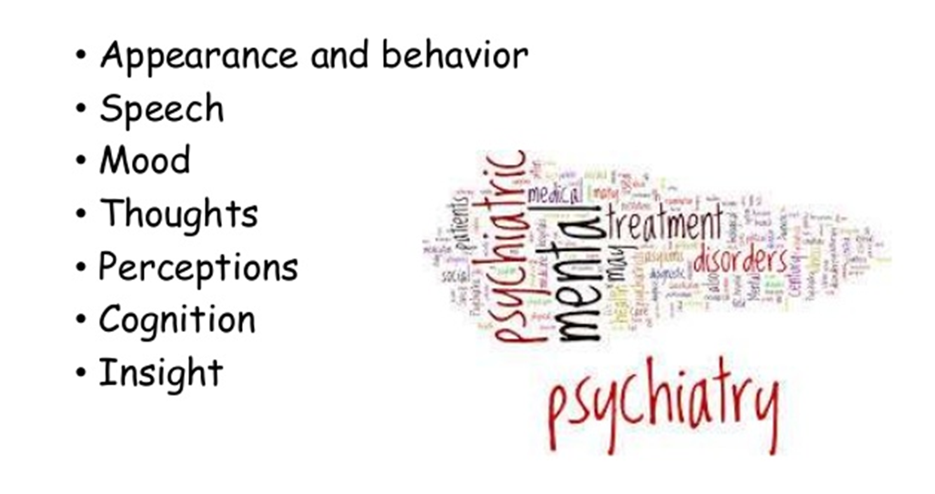

Or use the Mental State Examination Checklist 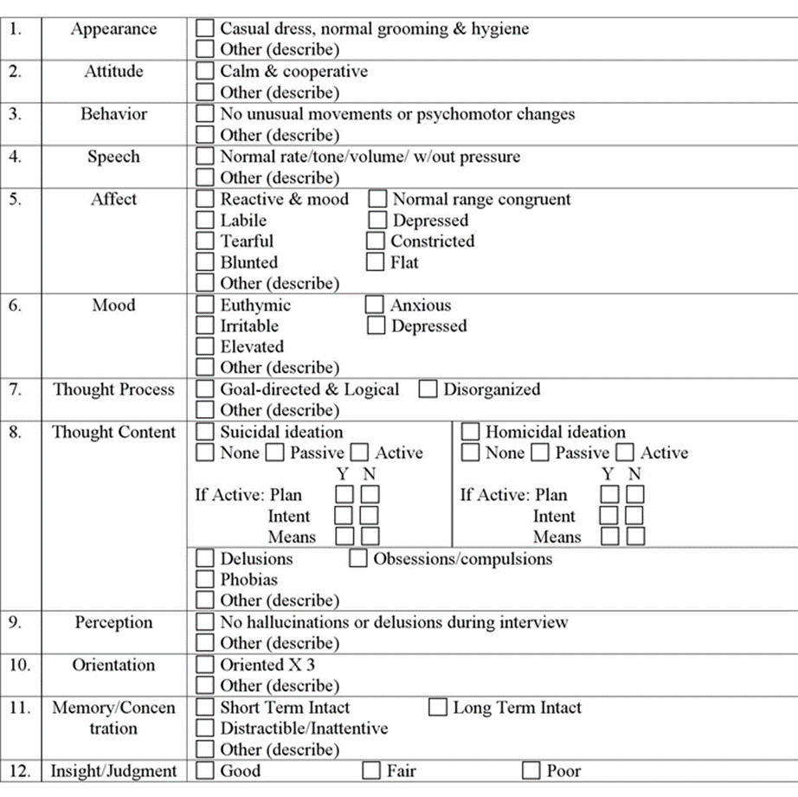
Complete this checklist and we can compare notes
If remote learning then students can click on the link when they have had a chance to complete the checklist

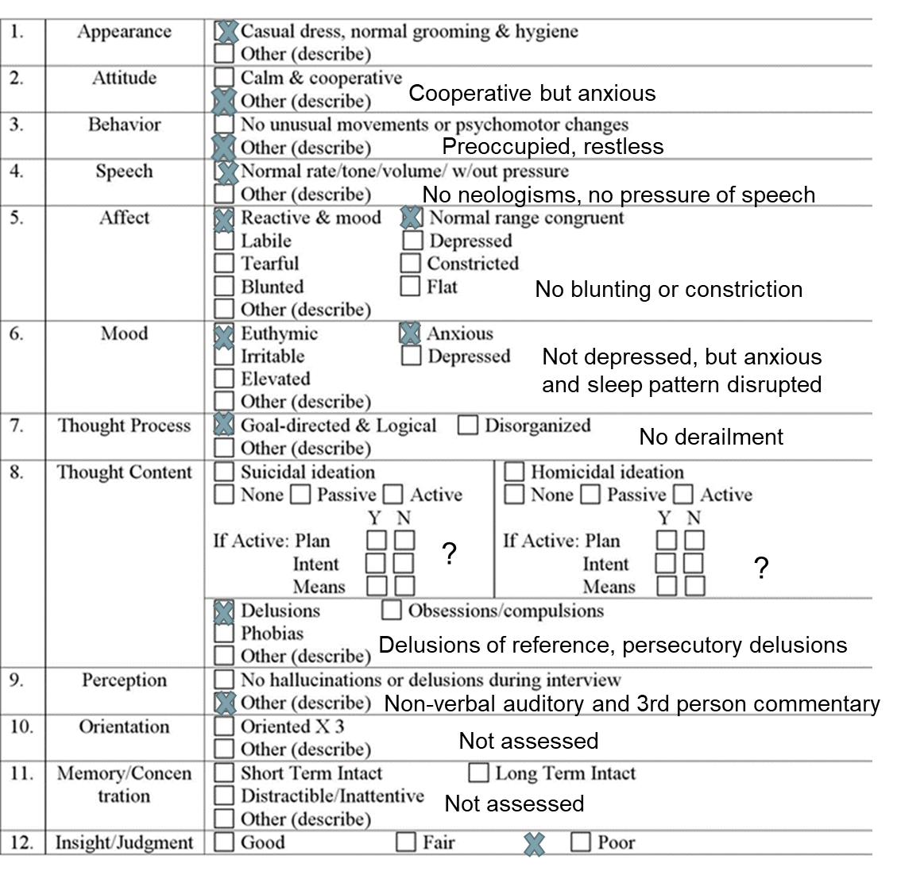
How would you describe his symptoms now?
He has no formal thought disorder – see slide from IOM week
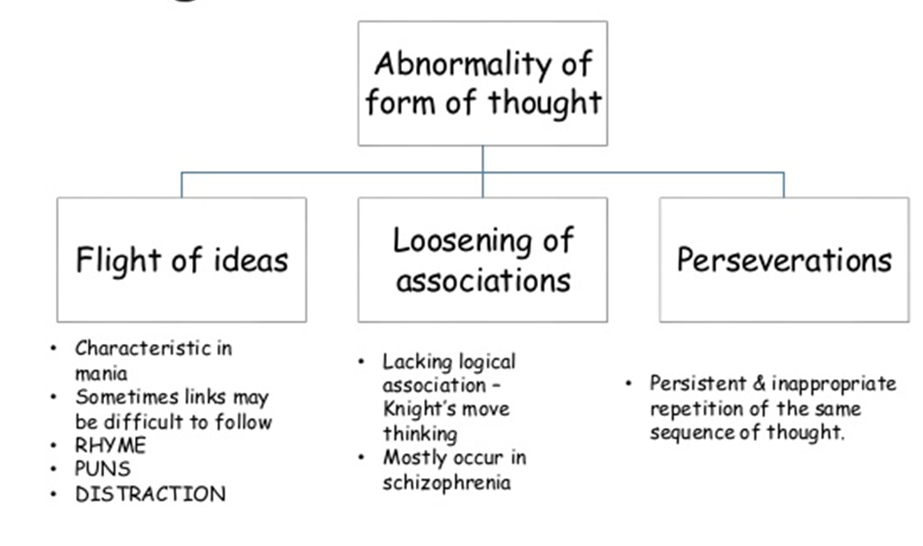
Delusional beliefs
– delusions of reference (TV, people at the window
- delusions of persecution (from neighbours). ‘Trying to find out how far they can push me’
Auditory hallucinations
– non-verbal ( hears a clicking when he makes a call)
- 3rd person commentary
Task 2: History taking
What points in his history would you focus on?
Write them down
Watch the rest of the video and summarise key points in his history
FH: Mother may have been depressed, Maternal Uncle likely had a psychotic illness as he was institutionalised. Has siblings who are well to our knowledge. Relationships not explored eg why is he not in contact with his family very much?
Personal history:
Normal milestones to our knowledge, apart from meningitis as a child.
Educated as far as University and, after initially taking English, decided to change to Philosophy
? did he gain his degree in the end.
? had he under-achieved
Drug and substance use: Minimal alcohol, but he smokes cannabis. The frequency and extent of his use needs to be further explored
What else would you like to know?
Write down the additional Qs you may have and we can compare notes
If remote learning, click on the link
Answer
Previous contact with Mental Health Services
- We need to know more about his student experience
- ? could there have been low-level paranoia earlier on as he makes refs such as ‘not a good place to study’
Probe question ‘Has anything like this happened before’? Or is it only since you have lived in your current place ..
Employment history
- He was a bit vague about this. What was he doing as a temp and why temping?
- ? has he left jobs because he felt he was being mistreated - he did mention somewhere was ‘not a good place to work’
Extent to which his symptoms are impacting on his daily life
- He is becoming more isolated and is avoiding going out
- ? how often is he actually leaving the house
- ? Is he shopping and cooking for himself
- ? Does he feel is begin watched and does it affect his personal care (ie avoid fully undressing/bathing)
- His symptoms appear to be impacting on his relationships, as his friends are anxious and have reached a point where they brought him to A&E.
Past and Current Risk history
- Risk to self ? suicidal ideation or self harm to relieve distress.
- Risk to others – he has confronted the neighbours on at least one occasion, you would want to find out more about the context of this and how confrontative he has been. Has he confronted anyone other than his neighbours?
- Does he currently have any plans ?
Forensic History – Include this in the risk history. He made reference to the police, find out what their involvement was and why.
What are the differentials?
What are the possible precipitating/perpetuating/protective factors?
Biopsychosocial Formulation
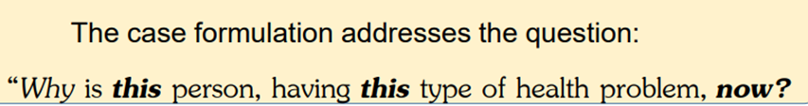
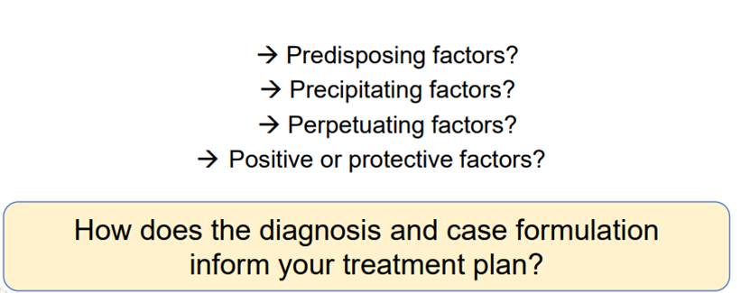

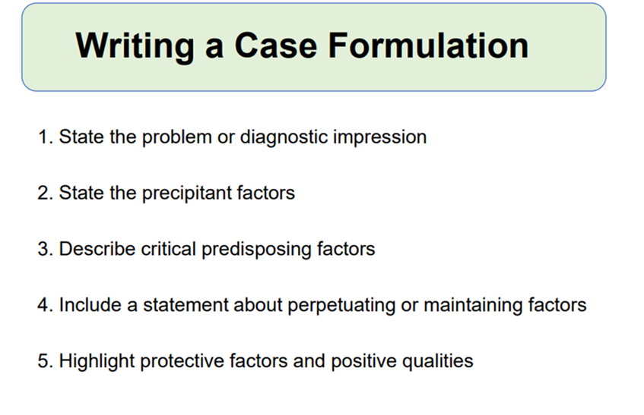

The biopsychosocial model considers the “4 Ps” for each of biological, psychological, and social:
- Predisposing factors
- Areas of vulnerability that increase the risk for the presenting problem. Examples include genetic predisposition for depressive illness and prenatal exposure to alcohol.
- Precipitating factors
- Stressors or other events (they could be positive or negative) that may be precipitants of the symptoms. Examples include conflicts about identity or separation-individuation that arise at developmental transitions, such as puberty onset or graduation from high school.
- Perpetuating factors
- Conditions in the patient, family, community, or larger systems that exacerbate rather than solve the problem. Examples include unaddressed relationship conflicts, lack of education, financial stress, and occupation stress (or lack of employment)
- Protective factors
- Include the patient’s own areas of competency, skill, talents, interest and supportive elements. Protective factors counteract the predisposing, precipitating, and perpetuating factors.

You may find it helpful to use a 3x 4 table
 | BIOLOGICAL FACTORS | PSYCHOLOGICAL FACTORS | SOCIAL FACTORS
PREDISPOSING FACTORS
PRECIPITATING FACTORS
PERPETUATING FACTORS
PROTECTIVE FACTORS

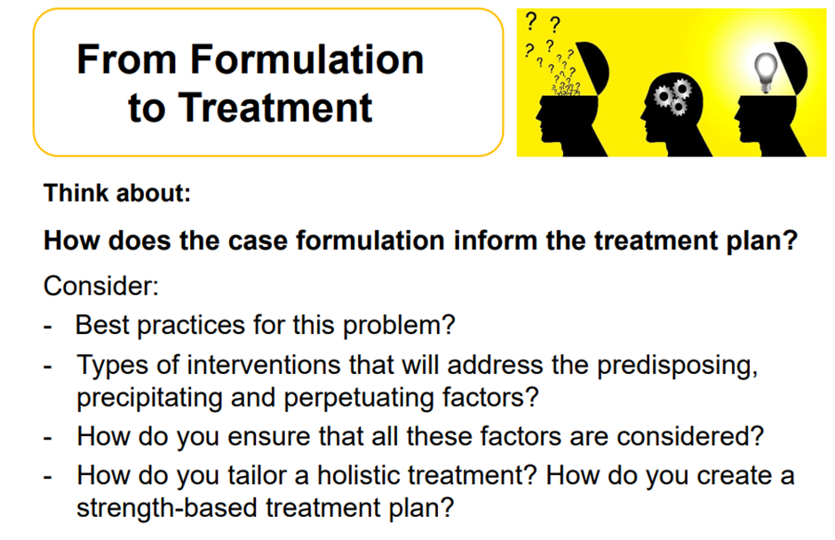

Let’s think about first episode psychosis
How common is it?
First episode psychosis occurs most commonly between late teens and late twenties, with more than three quarters of men and two thirds of women experiencing their first episode before the age of 35
What are ‘early intervention in psychosis’ services?
https://eur01.safelinks.protection.outlook.com/?url=https%3A%2F%2Fwww.youtube.com%2Fwatch%3Fv%3DGXh9hPzHHi4&data=02%7C01%7C%7C5d6735409d8948cc131a08d7ce982fcb%7C1faf88fea9984c5b93c9210a11d9a5c2%7C0%7C0%7C637205025344239513&sdata=2FFNQw4nVQRs38tUwizOj%2B%2FOV6ozNkuCBMQ3lQJTjEk%3D&reserved=0
WATCH THE FIRST 8 MINUTES AND THINK ABOUT THE TYPES OF SYMPTOMS DESCRIBED BY THE 3 INDIVIDUALS
Man on beach
? embed an SBA on Delusional Mood
? thought disorder, friends felt he was talking in metaphors
Grandiose delusions
Woman
? SBA on Command hallucinations
Man in the park
Manic episode, creative, ‘speeded up’, reaches a point where it is completely out of control

WATCH THE NEXT 7 MINUTES AND THINK ABOUT HOW THE EIS TEAM HELPED TO BREAK DOWN BARRIERS AND ENGAGE THERAPEUTICALLY.
Important themes:
- Ambivalence about early intervention service
- Role of the professional
- Being patient, flexible and ‘Just listening’
Multidisciplinary nature of the team:
- Employment specialist
- OT
- Support workers – bring their own experience of mental health
- Explains the nature of the role of the each MDT member
- Issues about housing – help with form filling

WATCH THE NEXT 7 MINUTES ON TREATMENT
Themes
- Therapeutic alliance
- Antipsychotic drugs
- Family interventions – help people give their own versions
- Recovery concepts
It is whatever people want it to be
Professionals should not impose their own version of recovery on others
A big part is working out how they stay well
Mental health is not just for people who ‘get caught’ – many people are living with symptoms they are able to hide better

NICE guidance (see PDFs):
Treatment and care for adults with psychosis or schizophrenia NICE Pathways Psychosis and schizophrenia © NICE 2020
- For people with first episode psychosis offer: oral antipsychotic medication in conjunction with psychological interventions (family intervention and individual CBT)

- Advise people who want to try psychological interventions alone that these are more effective when delivered in conjunction with antipsychotic medication.

- If the person still wants to try psychological interventions alone: offer family intervention and CBT agree a time (1 month or less) to review treatment options, including introducing antipsychotic medication.

- Continue to monitor symptoms, distress, impairment and level of functioning (including education, training and employment) regularly.

- Do not start antipsychotic medication for a first presentation of sustained psychotic symptoms in primary care unless it is done in consultation with a consultant psychiatrist

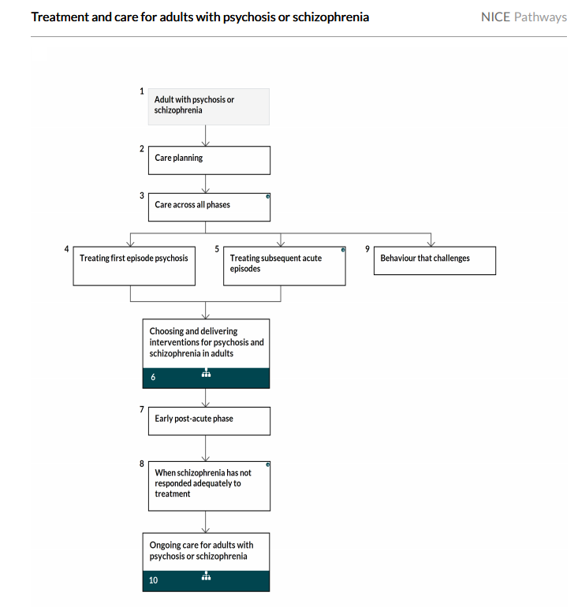

Related NICE guidance on interventions
Choosing and delivering interventions for psychosis and schizophrenia in adults:
NICE Pathways

