Psychiatry
Course Handbook
2020


Contents

1. The aims and objectives of the course

2. The core syllabus

Theme 1: Communicating with patients
Theme 2: Signs and symptoms of psychiatric disorders
Theme 3: Common clinical conditions,
Theme 4: Psychiatric Emergencies

3. The “Introduction to Clinical Psychiatry” sessions

4. Introduction to personal safety

5. The clinical attachment

6. Integrated Learning Activities (ILAs)

7. Assessment

8. Reading list & “Book / Flim Club”

This booklet has been produced in order to give direction and guidelines to both students and tutors involved in the Phase 3a psychiatry placement. We are always open to suggestions for improvements and constructive criticism is very welcome.

For queries please contact:

Medical School
Undergraduate Course Administrator (Mon, Tues and Wed)
Ms Sarah Turvey s.r.turvey@sheffield.ac.uk
Undergraduate Psychiatry Lead, Sheffield University
Dr Helen Crimlisk Helen.Crimlisk@shsc.nhs.uk

Sheffield

Undergraduate Administrator, Ms Sharron Crapper sharron.crapper@shsc.nhs.uk
Undergraduate Psychiatry Tutors:
Dr Kiran Pindiprolou kiran.pindiprolu@shsc.nhs.uk
Dr Reem Abed reem.abed@shsc.nhs.uk
Mr Gary McCulluck garymcculloch@shsc.nhs.uk
Ms Ellie Wildbore Ellie.Wildbore@shsc.nhs.uk

Barnsley

Undergraduate Administrator Ms Louise Hunt Louise.Hunt@swyt.nhs.uk
Undergraduate Psychiatry Tutor
Dr Kiran Rele kiran.rele@swyft.nhs.uk

Bassetlaw
Undergraduate Administrator, Ms Nicola Ackroyd nicola.ackroyd@nottshc.nhs.uk
Undergraduate Psychiatry Tutor
Dr Anu Pria anu.priya@nottshc.nhs.uk

Rotherham and Doncaster

Undergraduate Administrator, Ms Nicola Bird nicola.bird7@nhs.net
Undergraduate Psychiatry Tutors:
Dr Sathya Vishwanath sathya.vishwanath@nhs.net
Dr Zead Said zead.said@nhs.net
Dr Sonja Kruger sonja.kruger@nhs.net

Chesterfield

Undergraduate Administrator, Ms Helen Butler helen.butler9@nhs.net
Undergraduate Psychiatry Tutors:
Dr Madeleine Bonney-Helliwell Madeleinebonney@nhs.net
Dr Amy Herford Amy.Herford@nhs.uk
Mr Simon Rose Simon.rose3@nhs.net


1: The aims and objectives of the course

To give the student a proficient working knowledge of psychiatry and sufficient experience to undertake a structured psychiatric history and mental state examination (MSE), have a working understanding of common psychiatric problems, and have an understanding of the biopsychosocial approach in the management of common disorders

To support the student to achieve directed self-learning, and to take responsibility for finding a variety of learning experiences to support these aims

To inspire the student to take an interest in mental health as a vital component of wellbeing, which needs to be considered in all clinical settings, to enable a holistic, person-centred approach to care and treatment

To introduce students to the range of options available to those considering a career in psychiatry, and support those who wish to develop their knowledge through SSCs or other extracurricular activities

What is psychiatry? https://www.youtube.com/watch?v=MuW3OMR3BLs
My psychiatry placement: https://www.youtube.com/watch?v=HovW9eDvyR4
Why choose psychiatry? https://www.youtube.com/watch?v=--EGkhUqDGo
Choose Psychiatry - specialties https://binged.it/2q15EJk

If you’d like to deepen your understanding of psychiatry, we will help you organize this! An SSC can be clinically based in a particular subspecialty of psychiatry, or we can link you in with people who will help you undertake a service evaluation, audit, teaching or research as your SSC.

..\choose-psychiatry-careers-booklet---a5.pdf

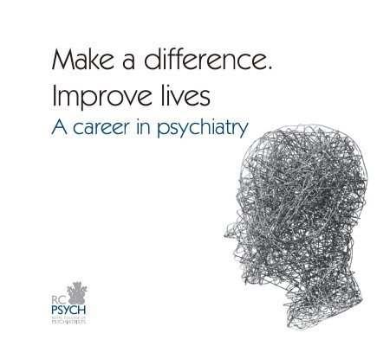
2: The core syllabus

By the end of the placement you should have the skills needed by a foundation doctor to recognize, assess and discuss mental health problems and diagnoses commonly encountered in practice, and have an understanding of the treatment options which may be helpful.

- Communicating with patients
- Signs and symptoms of psychiatric illness
- Common clinical conditions, their assessment and management
- Psychiatric emergencies

Theme 1: Communicating with patients

- Active listening
- Techniques in challenging situations (e.g. when patient is suicidal or agitated)
- Understanding non-verbal communication
- Giving information to patients sensitively

You will have acquired basic skills in communication, and we will help you develop these further through the Psychiatric Interview Skills session, and through opportunities to present, reflect on and discuss cases on placement.

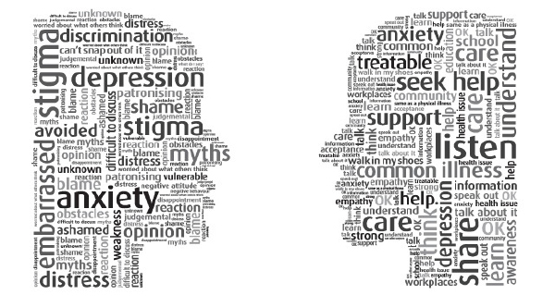
Theme 2: Signs and symptoms of psychiatric disorders

- Recognising and eliciting psychiatric symptoms
- Describing the signs elicited through a mental state examination (MSE)

Just as in other specialties, in psychiatry your assessment of a patient should be organised into a history and an examination.

The history is similar to what you have previously learnt about, but there will be more focus and depth on a range of areas relevant to the etiology and impact of mental health problems, such as early life experiences, traumatic events, coping strategies, relationships and risk issues.

The MSE is your description of the patient’s appearance, behaviour, thoughts and perceptions. You will need to have an understanding of terms below, commonly used in describing the mental state, and what they imply with regard to diagnosis.

Illusion  Hallucination  Over-valued idea  Delusion  Delusional perception  Thought alienation  Thought insertion  Thought withdrawal  Thought broadcast  Thought echo  Thought block  Hallucination  Illusion | Concrete thinking  Loosening of association  Circumstantiality  Perseveration  Confabulation  Somatic passivity  Made acts & feelings Delirium  Catatonia / stupor  Psychomotor retardation  Flight of ideas  Thought disorder | Poverty of speech  Poverty of thought  Pressure of speech  Anhedonia  Flattening of affect  Incongruity of affect  Blunting of affect  Belle indifference  Depersonalisation  Derealisation  Conversion/dissociation  Stereotypy/mannerism  Obsession/compulsion


Theme 3: Common clinical conditions

- Diagnostic classification systems used in psychiatry e.g. ICD 10
- Core problems in psychiatry
- Biopsychosocial approach to formulation and management

Please look at ICD 11 https://icd.who.int/browse11/l-m/en
You need to have an understanding of its content and be able to critique the concept of diagnosis. Don’t worry, you do not need to know ICD 10 numbers!

The core problems you need to know about as a medical undergraduate have recently been reviewed and updated. The complete list and learning objectives are available on Minerva.

- Addictive behaviours
- Personality and identity
- Anxiety
- Self-harm
- Mood problem
- Cognitive impairment
- Psychosis
- Learning disability
- Liaison (including eating disorders, somatization & gender disorders)

Each of these core problems will have associated index conditions (with an indication of how common and serious they are) to guide your learning.

Biopsychosocial Model

When considering assessment and management in psychiatry, you should pay particular attention to the biopsychosocial model.

Biological

You should take a holistic approach to assessment, in particular recognizing the role of physical illness and symptomatology in psychiatric settings, and the mental health problems commonly associated with physical health conditions.

You should have an understanding of the following aspects of pharmacology with particular reference to:

- Hypnotics
- Anxiolytics
- Antidepressants
- Antipsychotics (injectable and oral)
- Mood stabilizers
- Stimulants
- Illicit drugs and alcohol

In addition, you should be able to:

- Establish an accurate drug history, covering both prescribed and other medication including illicit drugs
- Demonstrate knowledge of drug actions: therapeutics and pharmacokinetics, drug side effects and interactions
- Prescribe drugs safely, effectively and economically
- Provide patients with appropriate information about their medicines
- Understand how errors can happen in practice, and the principles of quality assurance, clinical governance and risk management
- Understand the responsibility of the doctor within the current systems for raising concerns about safety and quality
- Have an understanding of the indications and practicalities of Electro-convulsive therapy (ECT)
- Know what relevant aspect of the physical examination should be undertaken
- Understand the interactions between physical & mental illness


Psychological

You should have an understanding of the common psychological therapies used in practice and know when they might be used.

- Counselling
- Psychoeducation
- Cognitive Behavioural Therapy
- Dialectic Behavioural Therapy
- Psychoanalytic Psychotherapy
- Group Therapy
- Family therapy

In addition, you should:

- Understand the psychological mechanisms which impact on how individuals relate to one another
- Understand the concept and types of psychodynamic defense mechanisms
- Have an appreciation of how to build rapport and how to adapt your communication style to the clinical situation encountered
- Understand the commonly used coping strategies and their benefits and risks
- Understand the concepts of transference and counter transference
- Develop your communication skills to ensure use of empathic and compassionate language


Social

You should have an understanding of the social determinants of health and the impact they have on mental health with particular reference to:

- Material and relative poverty & deprivation
- Social isolation
- Migration
- Unemployment
- Socioeconomic status
- Housing / homelessness
- Institutional care
- Racism & discrimination
- Criminal justice system
- Education
- Trauma and abuse
- Social capital
- Inequality

In addition, you should:

- Understand that being part of a minority group can increase your risk of developing mental health problems
- Appreciate the importance of choice of language in stigma
- Understand the differential impact of legislation on minorities
- Have an understanding of the ethical challenges faced in psychiatry and common dilemmas
- Recognize the public health value of building social capital
- Understand the value of prosocial behaviour, social integration and healthy relationships
- Recognize the importance of participation in decision making and self- determination


Theme 4: Psychiatric Emergencies

- Assess the patient’s potential danger to self or others
- Undertake and communicate a risk assessment
- Understand the principles of de-escalation
- Understand the concept of least restrictive option
- Use of the Mental Health Act
- The Mental Capacity Act

In addition, students should know how to recognize and manage the following emergencies, which may present in psychiatric settings:

- Alcohol withdrawal
- Delirium tremens
- Wernicke’s encephalopathy
- Lithium toxicity
- Acute dystonic reaction
- Neuroleptic malignant syndrome
- Seratonin syndrome
- Drug overdose
- Catatonia
- Acute confusional state

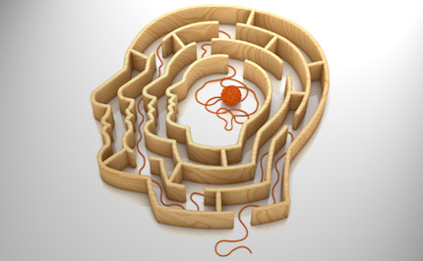
3: The “Introduction to Psychiatry” sessions

The 3-day Introduction to Psychiatry is really important and you should ensure this is attended in full. Each session is designed to build up your knowledge base and understanding of psychiatry. By the end of the introductory sessions, you should be adequately prepared to begin your clinical attachment. Please let us know if there are particular issues which mean you need more support in this area.

Med School – LT03 all day  9.00 – 10.15  Welcome to Psychiatry Module  (Dr Helen Crimlisk)  10.20 – 11.20  Undertaking a Psychiatric Assessment – History, Examination, Differential Diagnosis, Formulation and Management  11.25 – 12.25  Phenomenology in Psychiatry | Clinical Skills - Samuel Fox House, NGH, all day  9.40 – 11.30  Psychiatric Interview Skills in small groups led by Trainees, nurse educators, lived experience educators | Med School – LT03 all day  9.00 – 10.10  Dementia and Psychiatric Disorder in Older Adults Psychiatry  10.15 – 11.15  Psychiatry Treatments -  Psychological and Psychosocial Interventions  11.30 – 12.30  Child and Adolescent Psychiatry
 | LUNCH
1.25 – 2.55  Common Mental Health Disorders / Management in the Community  3.05 – 4.05  Public Mental Health  - – 4.15  Completion of IT forms for students based in Sheffield for Psychiatry – Groups A and B | 12.30 – 3.30  Students will rotate in groups through the following three sessions:  - Patient Encounter Session  - Personality Disorders Seminar  - Ethical Issues in Psychiatry Seminar  3.30  Informal Debrief -  (available for any student who wants to talk about the Patient Encounter session or other matters relating to the placement) | 1.30 – 3.30  Mental Health Act Simulation Session  3.35 – 4.35  Psychiatry Treatments:  Pharmacology
Outlines of Introduction to Psychiatry Sessions


Welcome to Psychiatry Module

You will be given an overview of the course and the assessment system, and we will explain what is expected from you.

At the end of the session you should:

- understand the aims and objectives of the course
- understand the relevance of psychiatry within medicine
- appreciate the role of language and stigma on patients
- understand the career pathways within psychiatry
- know how to get the most out of your psychiatry attachment
- know about opportunities for developing your interest in psychiatry


Undertaking a Psychiatric Assessment - History, Examination, Differential Diagnosis, Formulation and Management

You will learn about the key features of the psychiatric history and the Mental State Examination, and offer practical advice on clinical risk assessment.

At the end of the session you should:

- be able to outline the categories of a comprehensive psychiatric history
- know how to build rapport to facilitate a comprehensive history
- understand the components of the Mental State Examination
- appreciate the importance of relevant physical examination and investigation
- construct a differential diagnosis and articulate a formulation
- understand the components of a risk assessment and initial management plan

Phenomenology
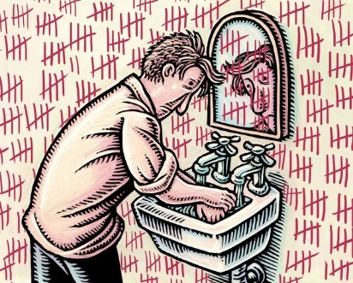
We will explore in detail the phenomenological terms used in the Mental State Examination (MSE) and their relevance in mental disorders.

At the end of the session you should:

- be able to explain the importance of the MSE
- understand how to describe altered states of mind
- be familiar with terminology used in descriptive phenomenology


Common Mental Health Disorders

You will explore the presentations of the most common mental health disorders, such as mood disorders and psychosis and their management.

At the end of the session you should:

- have an overview of common conditions
- understand the concept of formulation
- know how to think about differential diagnosis
- understand how to integrate history taking, phenomenology and classification

Public Mental Health

Public Mental Health consists of the promotion of well-being, prevention of future mental health problems and ensuring the best opportunity for recovery. This lecture will be a journey through interventions to enhance the mental health of individuals, families and communities using a public health approach.

At the end of this lecture you will:

- understand the role of health professionals in promoting public mental health
- have a working knowledge of public mental health interventions to help you in your practice
- have an understanding of the pros and cons of classification in mental health
- understand the concept of recovery as managing to live well rather than seeing recovery as cure

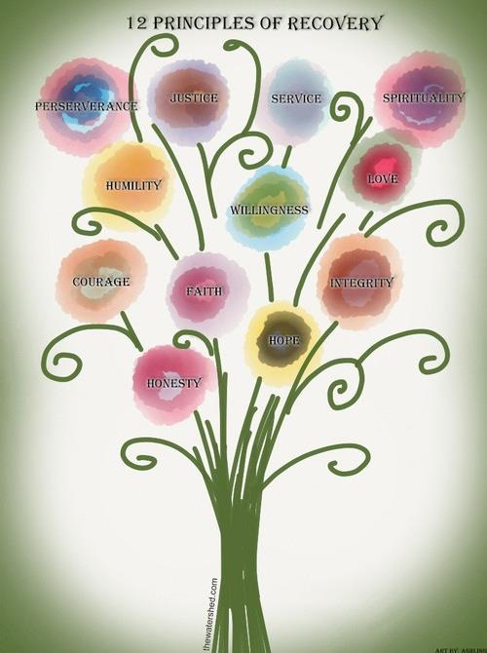
Treatments in Psychiatry: Psychological and psychosocial interventions

You will be given an overview of the different approaches which can be taken with regards to psychological and psychosocial interventions.

At the end of the session you should:

- know about a range of psychological interventions
- understand the potential benefits & harms of therapy
- know how to integrate interventions into a care plan
- understand the principal of recovery based work
- understand the role of other professions in the MDT
- know about the value of service user involvement in recovery


Treatments in Psychiatry: Psychopharmacology

You will learn about the major groups of psychiatric medication used in psychiatric practice, and explore their mode of action and side-effects.

At the end of the sessions students should:

- know about the main groups of medication used in psychiatric practice
- understand the scientific basis of the psychopharmacology
- understand the value and use of ECT

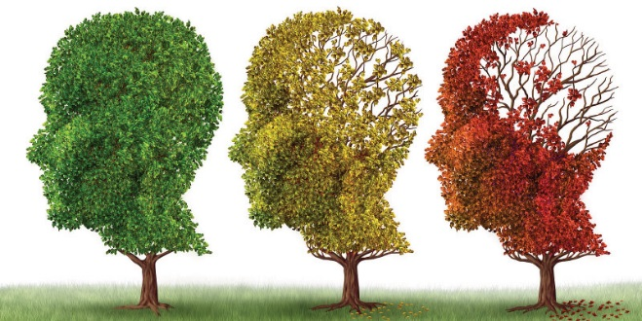
Dementia and Psychiatric Disorder in Older Adults

You will hear about the role of the psychiatrist in an older adult population, looking at the diagnosis and management of patients with cognitive impairment and mental illness.

At the end of the session you should:

- know about the assessment and diagnosis of cognitive impairment
- understand differential diagnosis and management in dementia and delirium
- understand how mental illness differentially impacts on older people
- understand the importance of the MDT in the elderly


Mental Health problems in Children and Young People

You will explore what differences there are in undertaking mental health assessments in children and young people. This session should dovetail with the teaching you get as part of your paedicatrics teaching, which will also cover elements of this.

At the end of the session you should:

- Understand the importance of developmental / cognition in assessing the mental health of children and young people
- Recognize opportunities and challenges in work with families and schools
- Have an outline of common mental health conditions in children and young people e.g. emotional disorders, conduct disorders and neurodevelopmental disorders.

The Mental Health Act (http://www.mentalhealthlaw.co.uk/Mental_Health_Act_1983)

You will learn about the structure and use of the Mental Health Act (1983). You will participate in a simulated interactive session on the use of the Mental Health Act in practice. You are encouraged to join in the spirit of this attempt to bring to life some of the ethical and practical considerations of sectioning a patient.

At the end of the session you should:

- know about Sections 2, 3, 5(2), 5(4), 135 and 136 of the Mental Act
- understand when the use of these sections is applicable
- know about the implementation and limitations of these sections
- understand how the rights of patients are protected

Interview Skills
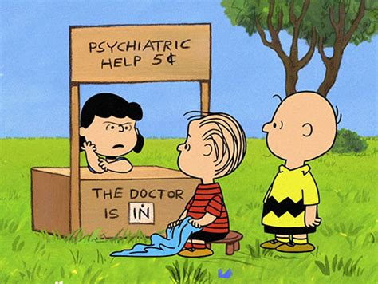
You will work in small groups with psychiatry trainees. You will role-play common scenarios to gain experience of talking to people with mental health difficulties. You will be given feedback on how to develop your own skills and confidence.

At the end of these sessions you should:

- be familiar with key interviewing skills
- be familiar with common types of psychiatric presentation
- have practiced asking difficult questions
- have experienced what it is like to be questioned about mental health issues.


Patient as Educator (PaE) Session

You will work in small groups with a PaE talking about their lived experience of mental health problems.

At the end of the session you should:

- have practiced taking a mental health history
- be able to describe elements of an MSE
- get feedback from your peers and The UoS Patients as Educators


Seminar: Personality

You will participate in a session to explore aspects of personality, personality disorder and some of the issues of working with people with personality disorder.

At the end of the session you should:
- have explored elements of your own personality
- considered how this impacts on your own interactions and behaviours
- understand the importance of personality in forming therapeutic relationships
- understand the concept & classification of personality disorder


Seminar: Ethical issues in Psychiatry

You will participate in a discussion to explore ethical issues which arise in psychiatry, and discuss some of the complexities of making decisions in such situations.

At the end of the session you should:
- have debated ethical issues in psychiatric practice
- have considered the role of ethics in your practice
- understand the value of articulating your thinking in
complex decision making

4: Introduction to Personal Safety & De-escalation Skills
Personal safety is an issue to be considered in all your clinical placements. You are at greater risk in A&E than on your psychiatry placement; however, as your psychiatry placement will include seeing patients in a variety of settings and at times of high distress, it is important to pay attention to the ways of minimizing risk of harm. The skills that you learn in psychiatry will help you understand the value of de-escalation and enable you to become more aware of your choices and options when in challenging situations.
Think about how you can improve your de-escalation skills – useful whatever specialty you are working in. See: https://youtu.be/Q4T-x1za6lg
This is a training film, in two parts, showing a range of de-escalation films being used by a nurse on a mental health inpatient unit. The first part shows poor practice, clearly demonstrating what it is a clinician might do, and what there might be in his response that makes a situation worse when faced with a patient who is highly aroused and distressed. In the second part, simple skills are used which rapidly de-escalate the same situation.
When watching the film, try and identify the factors that make things worse in part one and those that successfully de-escalate the situation in part two, breaking them down into environmental, non-verbal and verbal factors.
Behaviour:
- be polite and considerate at all times to patients, carers and staff
- introduce yourself to staff on placement and discuss who you are and what you are hoping to do
Preparation
- ensure you have had a local induction to clinical sites
- discuss patients you plan to see with a clinician in advance
- read the notes beforehand (often electronic) and inquire about risk
Personal
- clothes should be formal, non-restrictive and professional
- name badges should be worn on a lanyard
- avoid taking personal belongings, bags, drinks etc into clinical settings
Setting
- ask staff where to interview a patient (not normally at the bedside)
- consider going to interview patients in pairs (but this is not always necessary)
- consider room layout, open any “internal inspection” window
Interview
- introduce yourself & put the patient at ease (open questions initially)
- if a patient appears upset by a line of questioning, acknowledge this
- check if they are happy to continue
- practice your interview skills and seek feedback from peers and tutors
Escalation
- if you feel concerned or uncomfortable, then end the interview politely
- report back any concerns to clinical staff - do not keep it to yourself.
- if you do not feel your concerns have been heard, inform someone
5: The Clinical Attachment

During this time, you should gain experience of:

- working with the Multi-Disciplinary Team (MDT)
- out-patients, community, outreach teams
- ward work
- old age psychiatry
- emergency presentations (duty, liaison, on call experience)
- interviewing and presenting to peers or staff (at least 2 patients every week)
- discussions of formulation and management plans with staff / peers
- learning from people with lived experience or experts by experience
- ECT session (or simulation)
- specialist services (we can’t guarantee experience in all of these, but we can
arrange an SSC in ANY of them if you wish)

- drugs and alcohol
- learning disability
- liaison
- eating disorders
- maternal mental health
- rehabilitation
- forensic
- child and adolescent

Want to know more about the subspecialties in psychiatry?
Old Age: https://www.youtube.com/watch?v=VV_ur_vgYJo&t=2s https://www.youtube.com/watch?v=liK46AZU7m4
Liaison: https://www.youtube.com/watch?v=0HhtEYUbNPM&t=7s
Learning Disability: https://www.youtube.com/watch?v=eLrfgxykBos&t=4s
General Adult: https://www.youtube.com/watch?v=-0q30wP-t3Y&t=3s
Sports Psychiatry: https://www.youtube.com/watch?v=np2RHQtVbm0
Forensic: https://www.youtube.com/watch?v=aVKTB0UZecU&t=4s
CAMHS: https://www.youtube.com/watch?v=5UamSK0&t=3s

Research in Psychiatry: https://www.youtube.com/watch?v=jOB2p_HotoY

Anaesthetics to psychiatry: https://www.youtube.com/watch?v=zjg6vsXmUgA

Perinatal psychiatry: https://www.youtube.com/watch?v=SinOw310gWE

Attendance

The GMC and the Medical School require that we monitor your attendance on placement; therefore, all placement coordinators will note your attendance, and raise issues with the Medical School if there are concerns. If you are unable to attend because of sickness, please let the placement coordinator know on the day. If you want to apply for permission to not be on placement for any other reason, please contact Sarah Turvey (s.r.turvey@sheffield.ac.uk) in the first instance. Please note that whilst we will try to be understanding, it is your responsibility to request permission for any absence from placement in advance, and permission cannot always be granted.
If your attendance is unsatisfactory for any reason you will not pass the placement, and will be required to remediate.

“What to do when there’s nothing to do” on your clinical attachment

The placement administrators work hard to try to ensure there are timetables which provide you with a range of learning opportunities, but there are always times when planned activities don’t work out as hoped. If this occurs, please think of how you can use your time constructively.

THERE IS ALWAYS SOMETHING YOU CAN DO!

1. Ask the placement administrator/lead if there anything else you can do?

2. Ask if you can help out in any other way – review notes / summarize cases /audit?

3. Look up the electronic records of patient you have seen or are about to see

4. Ask if you can put your findings onto the electronic records (all placements are working towards giving you “Write Access” to medical records.

5. Take a look at the video resources (electronic)
- Assessing someone who is psychotic and dangerous in the community
- https://www.youtube.com/watch?v=Ga3OsA4uwa4
- How to undertake a suicide risk assessment in an inpatient setting https://www.youtube.com/watch?v=pK3rP49vhXI
- Self-harm MATES video
- https://www.youtube.com/watch?v=3KzzCS5b-cI
- Psychosis MATES video
- https://www.youtube.com/watch?v=8EJe32pKIpY

6. Do Suicide Awareness training https://www.zerosuicidealliance.com/training/

7. Do a Mock OSCE with your colleagues http://www.revisepsych.co.uk/osce1

8. Have a Case Based discussion with your peers about cases you have seen and write up your Clinical Cases + reflection in your portfolios

9. Read your Book / Film Club suggestion (see end)

10. Read up things you’ve not seen in the Medical Education library

6: Integrated Learning Activities (ILAs)

During your clinical attachment you will undertake problem-based learning in the form of Integrated learning activities (ILAs).

You should be familiar with the style of ILAs, which use a flipped classroom technique, for which you should arrive prepared to provide the bulk of the input for the session, while clinicians take on the role of facilitator. They are not lectures and should not be delivered didactically. Facilitation notes have been made available to help the Facilitators.

Whilst learning objectives have been developed for these ILAs, the nature of the flipped classroom method, means it may not always be possible to complete all of these in the time available. Please make sure you raise any issues you particularly want to cover.

The ILA topics map on to the core problems listed below:

Addictive behaviours
Personality and identity
Anxiety
Self-harm
Mood problem
Cognitive impairment
Psychosis
Learning disability
Liaison (including eating disorders)

7: Assessment

There are two aspects to assessment:

Formative - this refers to feedback which will help you to improve your performance, but does not count towards your final assessment. We will try and give this, but don’t be afraid to ask!

Summative - this refers to the placement based assessment and the end of year written examinations, which will decide on whether you have reached a satisfactory standard in phase 3a, in order to progress to the next phase of the course.

The Placement Based Assessment includes:

a) The Observed Long Case:

During your clinical attachment you are required to interview a patient whilst being observed by a senior medical member of the team. This is compulsory and you will have to show written evidence that this has been passed, in order to be signed off as having satisfactorily completed the attachment.

Guidance on the Observed Long Case for Students and Examiners

Principles:

The Observed Long Case (OLC) is a summative assessment.
The student should have had the opportunity to practise components of the OLC earlier in the placement (observed interview, presentation, case discussion).
The supervising consultant should ensure the OLC takes place for each student attached to his/her firm. In the case of leave this responsibility should be delegated in advance.
Opinion should be based on performance on the day, not on prior knowledge of the student.

Examiners should bear in mind the complexity of the patient case on the day, and that this is an undergraduate exam. They key aspects to be assessed are: building rapport, well-organised assessment, good use of time and the ability to present and discuss the case at the level expected by a Phase 3a student.

Aim:

Students are assessed on their ability to:
- Develop a good rapport with a patient
- Take a Psychiatric History and conduct a Mental State Examination in the time allowed
- Discuss issues around formulation, diagnosis, risk, investigation and management

Role of the Examiner

- The assessment should take place in week 5 of the attachment
- The examiner should arrange a suitable time and patient for the assessment
- The examiner should be a consultant, an experienced SAS, or higher trainee
- If necessary, a resit should be arranged with a different consultant examiner in week 6

Role of the Student

- The student should ensure they have a clear time and place for assessment confirmed
- The student is encouraged to take notes, but is not permitted to use a list or proforma
- The student should bring paperwork necessary to be completed at the time of assessment – this should be online from January 2019.

The assessment

- The student should have no prior knowledge of this patient /service user.
- Verbal consent should be sought for the assessment from the patient / service user
- The student has 1 hour to undertake a history and examination
- The student is expected to manage the process without the examiner’s assistance
- The examiner should be present for the whole of the assessment.
- The patient / service user should be invited to feedback about the experience before leaving
- The student should present the mental state and a formulation to the examiner, offer a differential diagnosis and discuss investigations, risk and management plan
- Physical examination is not expected, however this issue may form part of the discussion
- The examiner should give constructive feedback and suggest areas for improvement.

b) The Clinical Attachment feedback

At the end of your attachment your tutors will complete the clinical attachment proforma based on a range of clinical and professional skills. This will also reflect your attendance and engagement with the learning opportunities offered, as well as your professional behaviour. Poor attendance will jeopardize this.

c) The Clinical Cases & Reflection in the Electronic Portfolio

You are required to write up and reflect on clinical cases in your electronic portfolio.

In your psychiatry placement you are required to write up a minimum of six clinical cases which is the equivalent of one clinical case per week.

We suggest one clinical case each on depression, psychosis and self-harm and other cases of your own choosing.

The benefits of writing up clinical cases would be to help you to develop your history-taking skills and skills around formulation, diagnosis and management in preparation for the observed long case. The format used will also enable you to reflect on clinical cases and derive learning points, and in doing so, will prepare you for becoming doctors.

To support this, case-based discussion groups will run during the placement, facilitated by consultants or higher trainees for you to present and discuss your cases peer to peer. Your clinical cases will be looked at by one of the Clinical Tutors at the end of your placement, and may be looked at by your PATs tutor.

How to reflect?
You have already been given advice on this – look it up again?
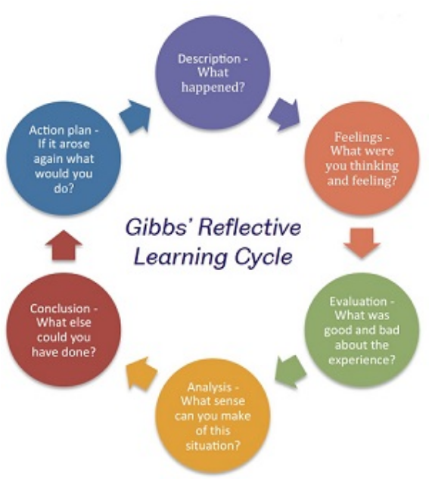
https://www.sheffield.ac.uk/ssid/301/study-skills/university-study/reflective-practice

There is a template available on your electronic portfolio in the “clinical cases” section. You will need to give a summary of the history, summary of mental state examination, management plan, investigations, results and outcome, to produce some learning points and a reflection e.g. the emotional impact of your interaction with the patient, or a reflection on your own learning needs. All clinical cases should be anonymised to ensure patient confidentiality.

We recognises that there has been some anxiety about reflection following the Dr Baba Gawa Case, and refer you to the GMC Guidelines in order to ensure that you do this safely but maintain the benefit of reflective practice.

https://www.gmc-uk.org/news/news-archive/new-guidance-to-help-you-with-reflection

The written examination

This will comprise of SBAs (Single Best Answers) and SAQs (Short Answer Questions) that will take place at the end of the year.

8: Reading List & “Book /Film Club”

We place particular value on the understanding of personal narrative in getting insight into mental illness from the perspective of the patient or service user. To support this, you will be asked to read a personal narrative to discuss and reflect on in a “Book / Film Club” Seminar. Please be guided by your placement lead as to how this is undertaken on your placement. The following are some of the texts recommended:

The Centre Cannot Hold – my journey through madness Elyn Saks
https://brainmaster.com/software/pubs/brain/The_center_cannot_hold.pdf

This is a powerful first person narrative which presents a number of challenges to stimulate debate, including issues of diagnosis, stigma, restrictive practice and restraint in the UK and the USA, psychotherapy and pharmacotherapy and principles of recovery. The book is available FREE online and a TED talk of Professor Saks describing her life is also available.
https://www.ted.com/talks/elyn_saks_seeing_mental_illness

The Other Side of Silence: Linda Gask
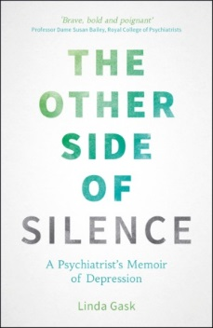
Psychiatrist, Professor Linda Gask, shares her experiences of therapy from the point of view of a mental health professional providing therapeutic services, and from her own experience as a patient having therapy to help her with depression.

https://lindagask.com/
https://www.youtube.com/watch?v=_GvMh2yQsRA

The Outrun: Amy Liptrot

Amy Liprop tells of a life in London which went wrong: alcoholism: broken relationships, lost jobs, trouble with the police, dangerous situations, and, most of all, spiraling loneliness. After repeated attempts to stop drinking, she saw her GP and was referred to a rehab programme in east London. https://www.theguardian.com/books/2016/jan/17/amy-liptrot-outrun-i-swam-in-the-cold-ocean-orkney-alcoholism

A little life: Hanya Yanagihara
https://www.theguardian.com/books/2016/jan/20/a-little-life-why-everyone-should-read-this-modern-day-classic

Generalized anxiety and dread is in the atmosphere. In the new godless world, there are no fixed external points or a commonly held set of beliefs; all that was solid has long ago melted into air. Generation Y, raised with the promise of an extraordinary life – a spectacular career, freewheeling adventures, money, love, the lot – has found that promise undelivered.
There are also many blogs on the internet which share personal experience of mental illness and distress and these can be very helpful, both giving hope to those struggling and insight to those trying to assist.

https://www.mentalhealth.org.uk/stories/
http://www.storyingsheffield.com/
(see http://www.storyingsheffield.com/stories/in-my-own-words-narrative-masterclass/ for 3 B Masterclass on this subject)
https://sheffieldflourish.co.uk/stories/
http://world-schizophrenia.org/stories/

And also some great novels dealing with mental illness which we’ve been exploring in the Sheffield #traineepsychiatrybookgroup.

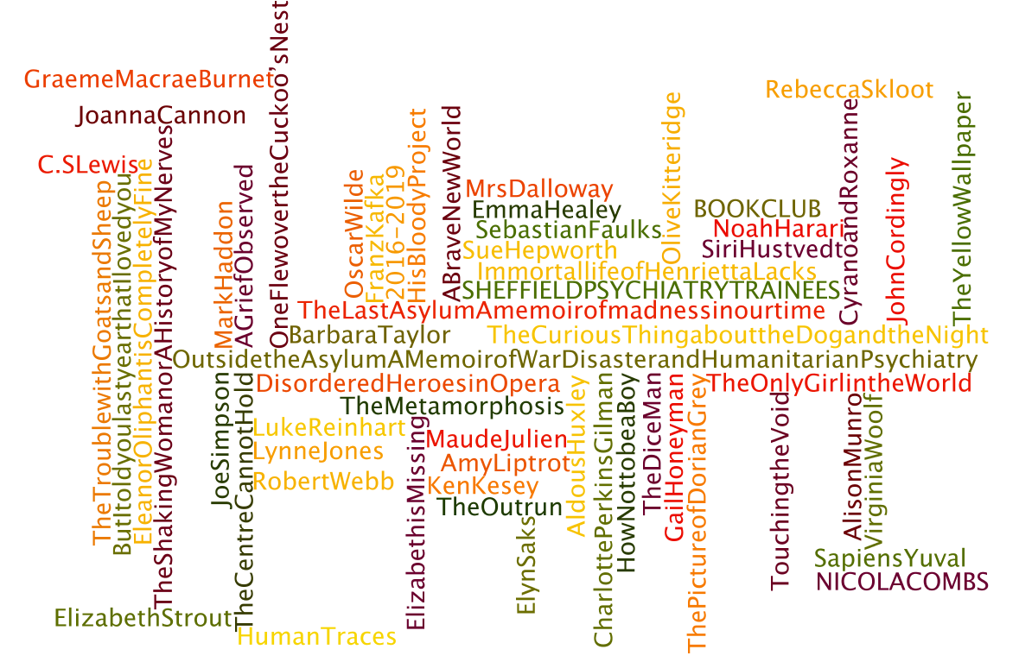

There are also many great films which will help your understanding of what it feels like to live with mental illness.

Films
A Beautiful Mind
Centre Cannot Hold
The Joker
One Flew over the Cuckoo’s Nest
Iris
Girl, Interrupted
Suddenly, Last Summer
A woman Under the Influence
I Never Promised You a Rose Garden
Play Misty for Me
The Remains of the Day
Matchstick Men
The Perks of Being a Wallflower
Infinitely Polar Bear
Inside Out
Welcome to Me

Academic background reading will also be necessary to support the on-placement teaching which will not cover all conditions, and we also recommend a range of videos and online sources to support your learning.

Oxford Handbook of Psychiatry
Semple and Smyth, 4th Ed – Oxford University Press, 2019

Synopsis of Psychiatry
Kaplan and Sadock, 11th Ed – Lippincott, William and Wilkins, 2014

The Shorter Oxford Textbook
Philip Cowen et al, 7th Ed – Oxford University Press, 2017

Psychiatry: a clinical handbook
Azam, Qureshi , Kinnair Scion Publishing Ltd 2016

Textbook of Psychiatry
Basant et al, 3rd Ed, - Churchill Livingstone, 2011

Sim’s Symptoms in the Mind
6th Ed, Elsevier Health Sciences, 2018

Choose Psychiatry - resources and information from RCPsych
http://www.rcpsych.ac.uk/discoverpsychiatry/acareerinpsychiatry/choosepsychiatry.aspx

Discover Psychiatry – getting the best out of your psychiatry placement
http://www.rcpsych.ac.uk/discoverpsychiatry/acareerinpsychiatry/medicalstudents.aspx

I.C.D. 11 Classification of Mental and Behavioural Disorders
https://icd.who.int/browse11/l-m/en

NICE Clinical Guidelines for psychiatric disorders
https://www.nice.org.uk/

What’s the evidence on a mental health issue Ask the Mental Elf (yes..)
https://www.nationalelfservice.net/mental-health/

Watch the films on mental state examination
http://www.bristol.ac.uk/medical-school/hippocrates/psychiatry/mse_etc/

Watch films on common psychiatric conditions and interview techniques
https://www.youtube.com/watch?v=ZB28gfSmz1Y

Watch a film on ECT -
“Electroconvulsive therapy has a controversial history, however it still has a place in clinical psychiatry and is used in life threatening clinical psychiatric conditions. It can be difficult to experience on your placement as not all services have an ECT suite and its use is not predictable. This video should help you understand more about its modern use. “
https://binged.it/2OQhcaB

Common Psychiatric Presentations in Emergency Settings
Self-harm MATES video
https://www.youtube.com/watch?v=3KzzCS5b-cI

Psychosis MATES video
https://www.youtube.com/watch?v=8EJe32pKIpY

Information for medical students
http://rcpsych.ac.uk/discoverpsychiatry/acareerinpsychiatry/informationformedstudents.aspx

Royal College of Psychiatry: Mental health information for all
http://rcpsych.ac.uk/expertadvice.aspx

Become a RCPsych Student Associate for FREE! http://www.rcpsych.ac.uk/discoverpsychiatry/studentassociates.aspx

FREE online subscriptions to the British Journal of Psychiatry and the Psychiatric Bulletin, discount on College publications, FREE annual conference & e-newsletter

Want to get more involved locally?

Sheffield PsychSoc
https://su.sheffield.ac.uk/groups/medics-psychiatry-psychsoc
@SheffPsychS

Engage your Mind
Local seminars for those interested in learning more about psychiatry as a career
https://twitter.com/EymPsychiatry
@EngageYourMind

Psychiatry Early Exposure Programme in Sheffield
Experience and seminars for students throughout their course
@PeepSheff

Contact: Dr Helen Crimlisk Helen.Crimlisk@shsc.nhs.uk
Phase 3a Psychiatry Lead

Or Ms Sarah Turvey s.r.turvey@sheffield.ac.uk
Undergraduate Course Administrator (Mon, Tues and Wed)

